About Creative Kinesiology

Discover what your body wants to say within a Creative Kinesiology session. Creative Kinesiology is a branch of kinesiology which helps you talk to your body, and find out what it is trying to tell you. We call this body-tracking.

Why not try Creative Kinesiology if you:

* have an ongoing problem that doesn’t seem to resolve
* are interested in preventing ill health
* wish to be full of energy to live life to the full

# **What to Expect in a Session**

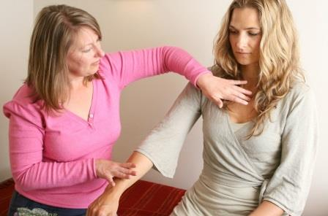

### What happens in a session?

You start with an initial consultation, where your practitioner will take your case history and you can share your story. This could be anything:

* an actual physical problem
* something nutritional (e.g. a food intolerance/sensitivity)
* low energy or mood, feeling off colour
* anxiety about the environment or the world we live in
* perhaps your feelings about a past event
* an inherited issue
* a stress-related situation at work or home

Your practitioner will help you talk to your body so you can find out the best way to restore balance and feel better. This may be bodywork, energy balancing, looking at making changes to your diet, or your environment, simple exercises to do at home. Gentle non-invasive healing techniques are used within the session to release stress.

Sessions last between 1 to 1½ hours - the length of session depends on the individual practitioner.

### 

### 

### How is this style of kinesiology distinct from others?

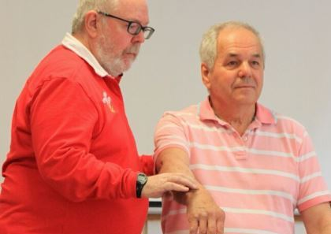

Our body-tracking approach helps you talk to your body’s wisdom

Body-tracking helps you to listen to what your body is saying.

We encourage you to talk about how you are feeling… and we listen.

We think bodywork is key to releasing stress and trauma so healing can occur.

Our practitioners listen deeply, they are trained in therapeutic skills.

We don’t do quick fixes - we like to work with you over a series of sessions.

We work with you in a co-creative way that involves you in the process.

Creative Kinesiology's unique way of working involves tracking, witnessing, holding and storytelling skills.

Would you like to know more about Creative Kinesiology?

Learn about the [unique Creative Kinesiology approach](https://creativekinesiology.org/about-creative-kinesiology/how-is-ck-unique/) to healing and self-development

Find out [what to expect](https://creativekinesiology.org/about-creative-kinesiology/what-to-expect/) in a Creative Kinesiology session

Then go to our web page

www.creativekinesiology.org

to find your local practitioner.

Contact us

Creative Kinesiology Association  
18 Moormead  
Budleigh Salterton  
Devon  
EX9 6PZ  
07897 554654  
  [info@creativekinesiology.org](mailto:info@creativekinesiology.org)



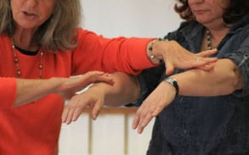

Talking to your body’s wisdom

Explore Creative Kinesiology’s body-tracking approach to health and wellbeing.

© 2020 Creative Kinesiology Association